1. Look through the String source code
2. **[OPTIONAL]** Read chapter #15 about Strings of ‘Java: The Complete Reference - Herbert Schildt’
3. Learn format specifiers and flags for string formatting. Link to official oracle docs - <https://docs.oracle.com/javase/8/docs/api/java/util/Formatter.html>   
   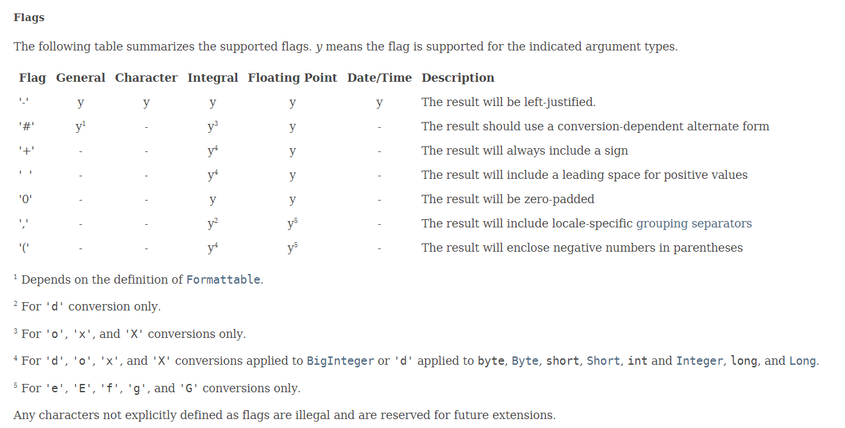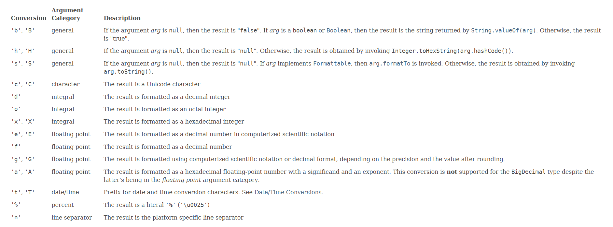
4. Look through the source code of formatting examples   
   <https://github.com/AndriiPiatakha/learnit_java_core/blob/master/src/com/itbulls/learnit/javacore/string/FormatterDemo.java>
5. Implement console program which meet the following requirements:
   1. Program starts and prints Math.PI five times in console output
   2. The first Math.PI contains only one fraction digit
   3. The second Math.PI contains two fraction digits
   4. The third time Math.PI contains three fraction digits
   5. The fourth time Math.PI contains four fraction digits
   6. The fifth time Math.PI contains five fraction digits
6. Learn regular expressions with this service: <https://regexone.com/>   
   Complete 15 lessons. Take hints and look solutions if needed.
7. Use this online tool to practice your skills in regular expressions - <https://regex101.com/>
8. Implement console program which meet the following requirements:
   1. Program starts and asks user to input any text
   2. Program prints array of words entered by user without any spaces or punctuation marks